URL Repositorio: https://github.com/darkJCdark/INF384-lab3-20206234
Sección 5:
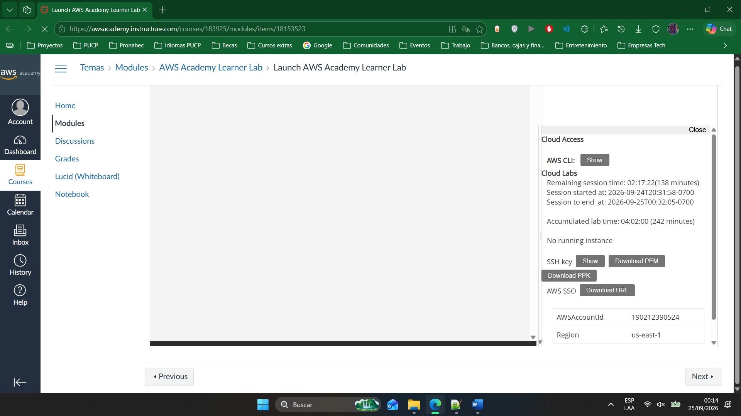

Sección 6:
https://github.com/darkJCdark/INF384-lab3-20206234/actions/runs/36092270910

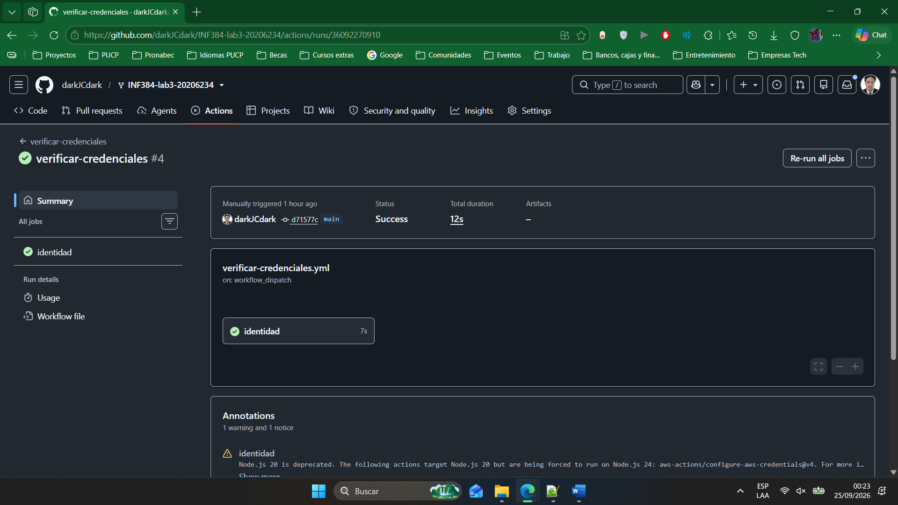

https://github.com/darkJCdark/INF384-lab3-20206234/actions/runs/36092028471
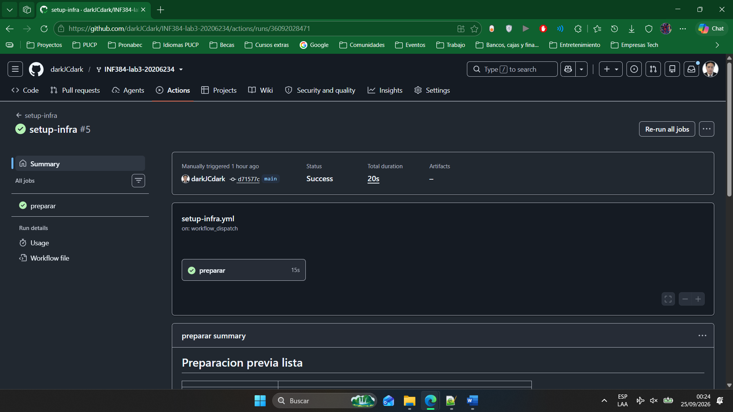

Sección 7:
A1: https://github.com/darkJCdark/INF384-lab3-20206234/actions/runs/36065998641
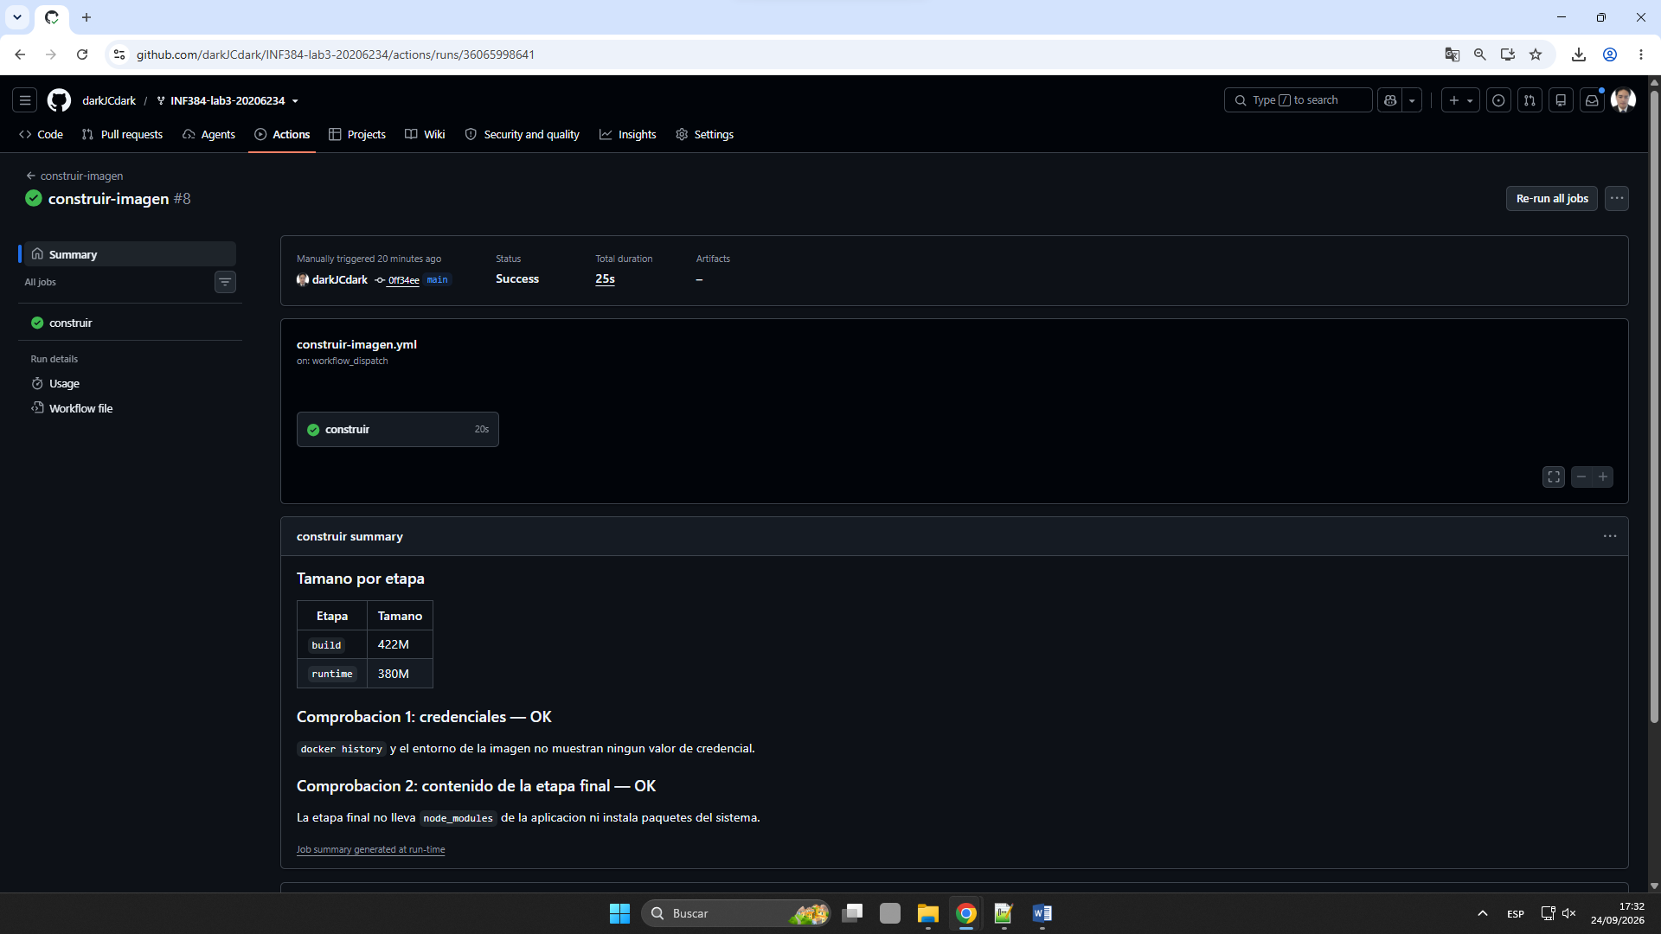

A2: https://github.com/darkJCdark/INF384-lab3-20206234/actions/runs/36068742138
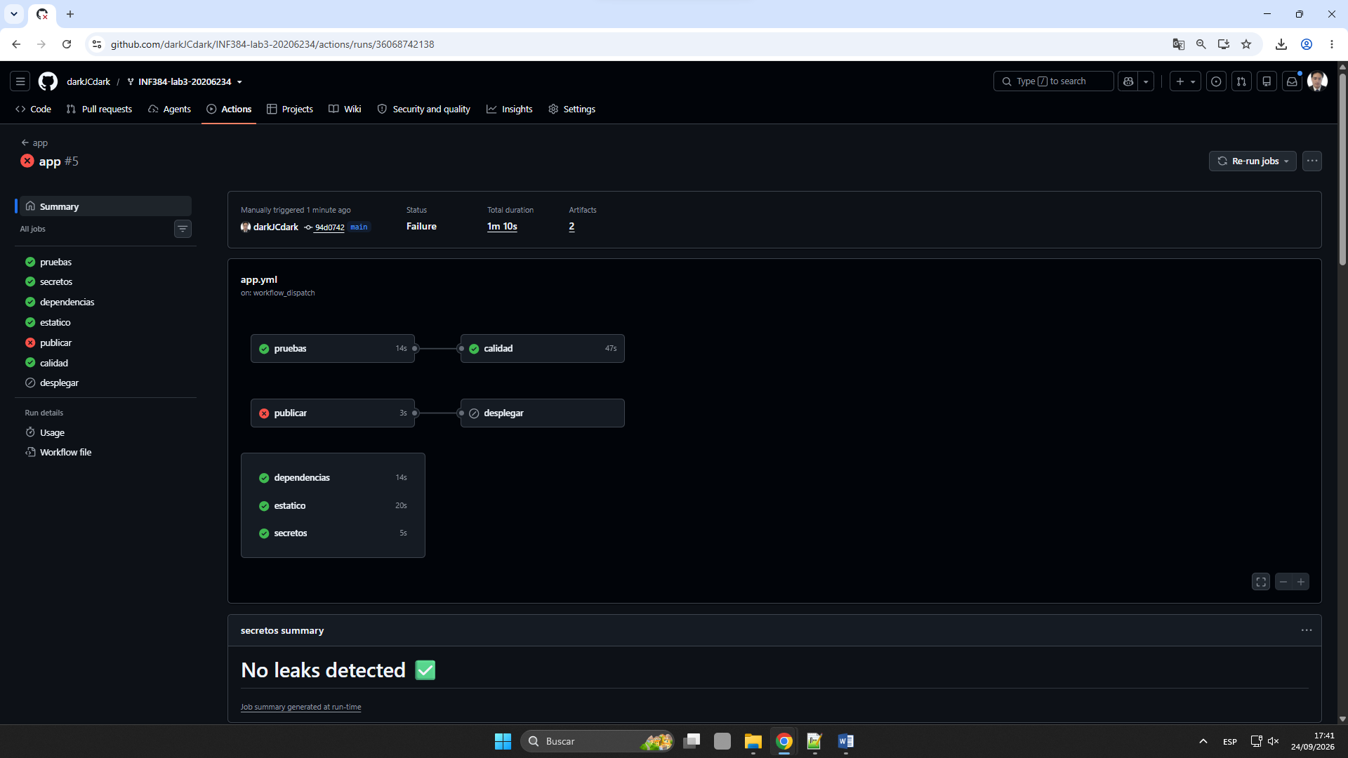
A3: https://github.com/darkJCdark/INF384-lab3-20206234/actions/runs/36093840498
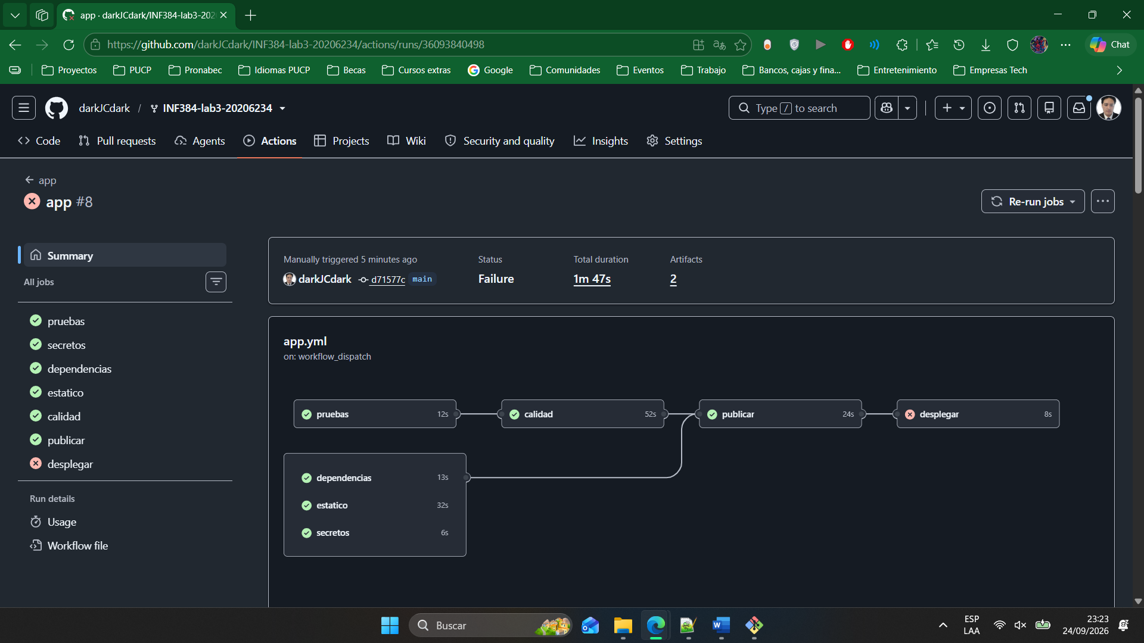

Sección 8:
B1: https://github.com/darkJCdark/INF384-lab3-20206234/actions/runs/36095464419
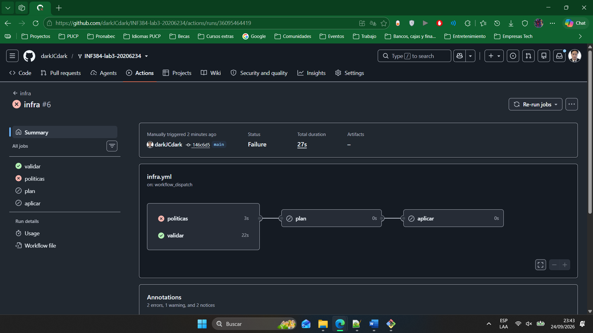

B2: https://github.com/darkJCdark/INF384-lab3-20206234/actions/runs/36095853351
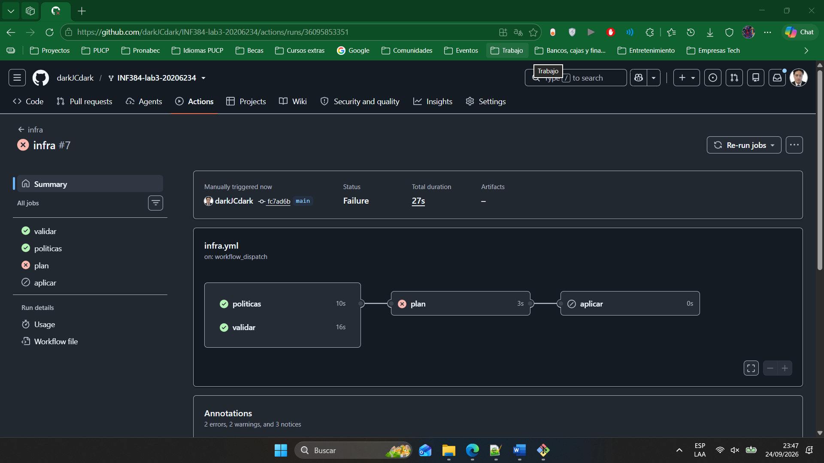

B3: https://github.com/darkJCdark/INF384-lab3-20206234/actions/runs/36096016476
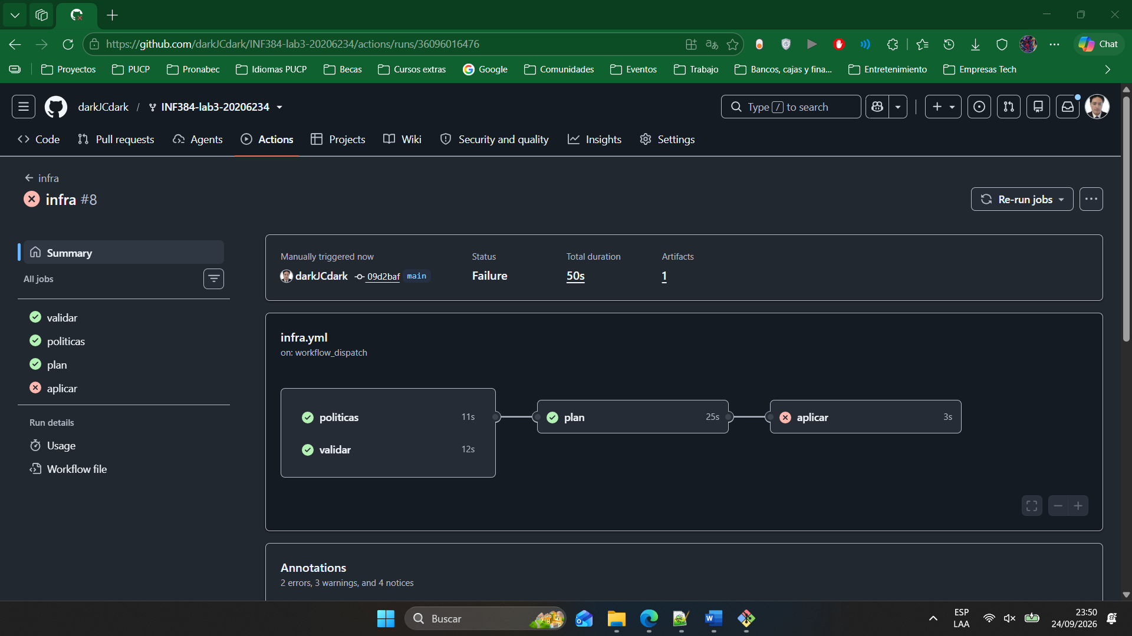

B4: Increase CloudWatch log retention and Lambda memory size · darkJCdark/INF384-lab3-20206234@de8d332
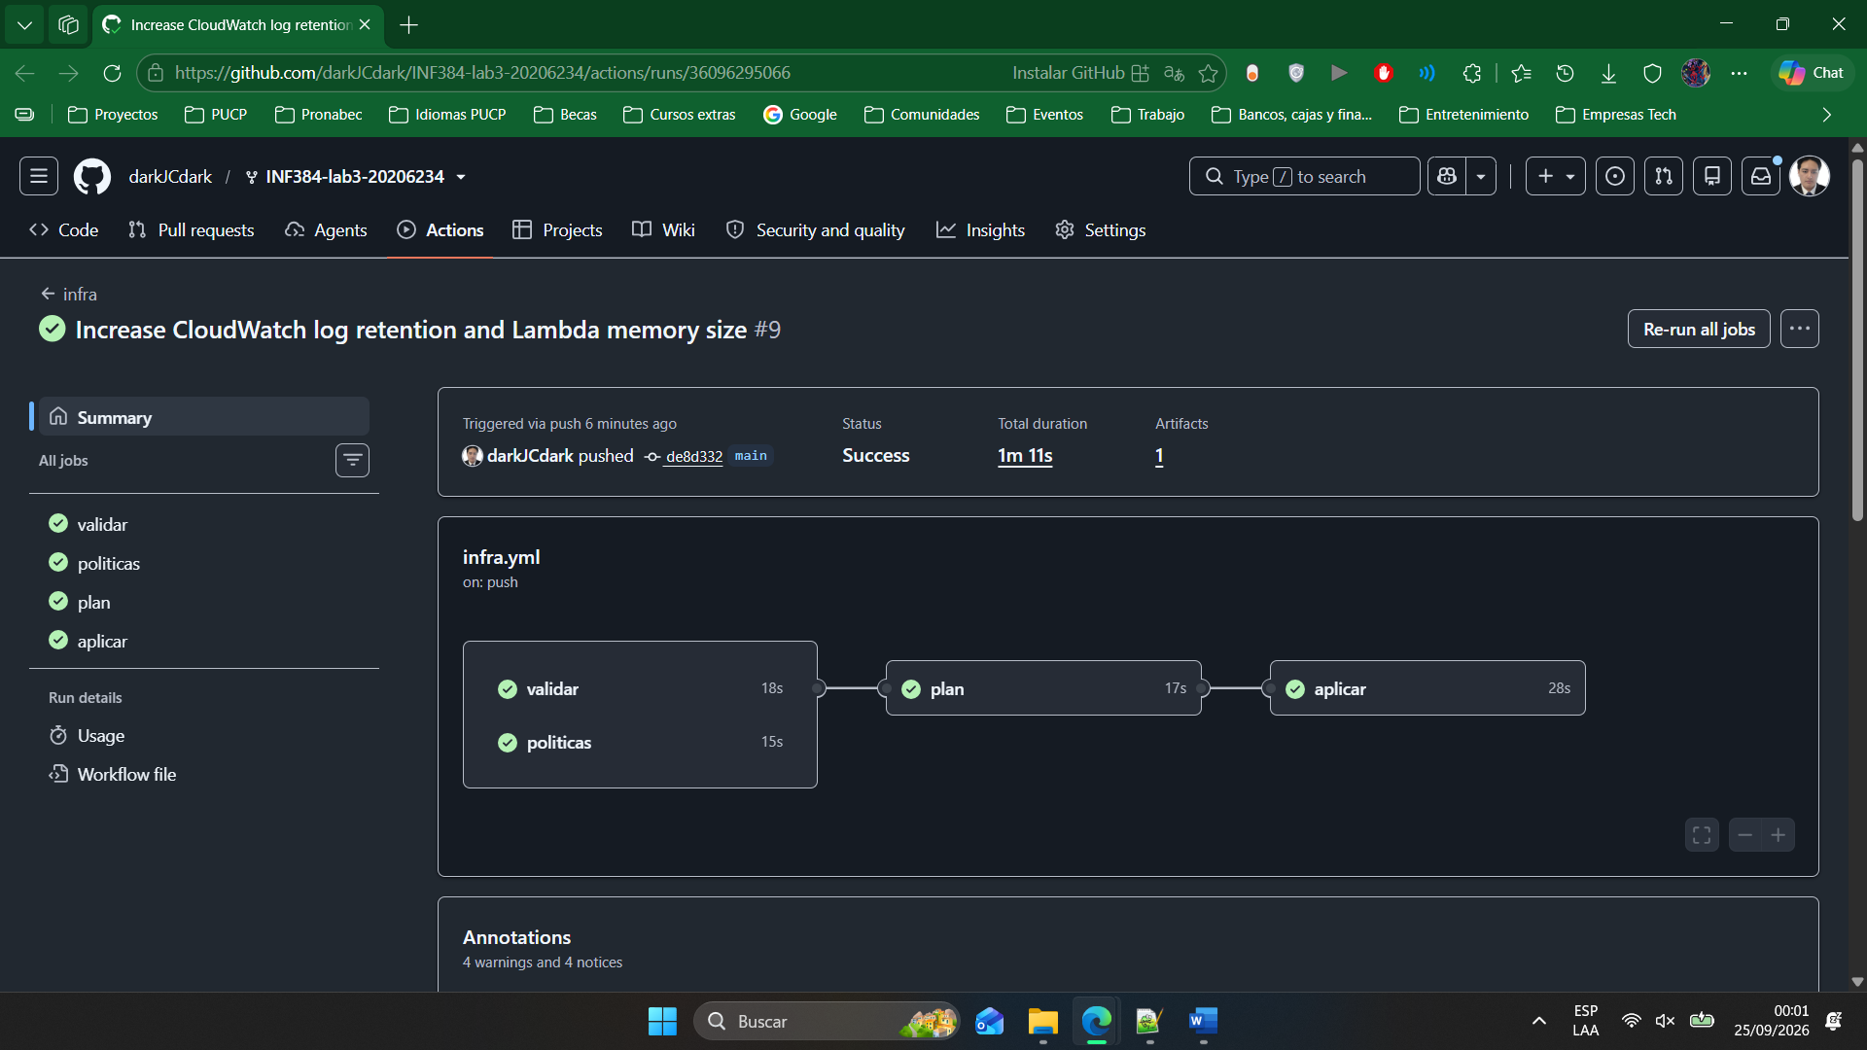

Sección 9:
Inyección 1: https://github.com/darkJCdark/INF384-lab3-20206234/actions/runs/36096549608
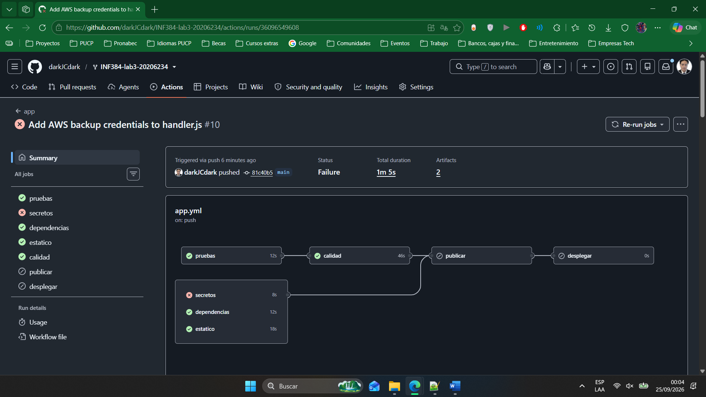

Inyección 2: https://github.com/darkJCdark/INF384-lab3-20206234/actions/runs/36096582244
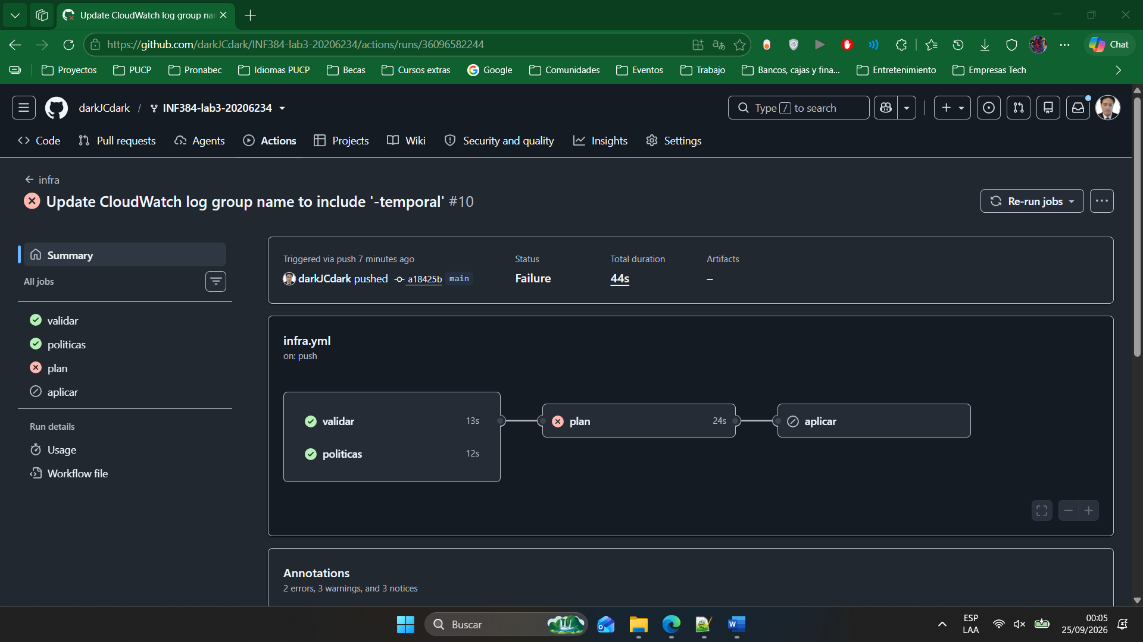

Commits
https://github.com/darkJCdark/INF384-lab3-20206234/commits/main/
